Burp Suite
Web Proxy Setup, Interception & Request Manipulation
Personal Lab Notes

1. What Is Burp Suite?
Burp Suite (pronounced “Burp Sweet”) is the most widely used web proxy tool for web application penetration testing. It sits between the browser and the back-end server as a man-in-the-middle (MITM) tool, letting us see, capture, and manipulate every HTTP request and response that passes between them.
It has a clean interface, a built-in Chromium-based browser that comes pre-configured to work out of the box, and is powerful enough for most testing needs even in its free Community Edition.

Why Use a Web Proxy
Once Burp is set up as a proxy, we can:
- See every HTTP request the browser sends and every response the server returns
- Intercept a specific request to pause and edit it before it reaches the server
- Observe exactly how the back end reacts to changes — useful for spotting bugs and vulnerabilities such as command injection, SQLi, auth bypass, and more
- Replay and tweak requests repeatedly without re-doing the action in the browser each time

Community vs. Pro
The free Community Edition covers nearly everything needed for standard testing. Paid-only features in Pro/Enterprise include:
- Active web app vulnerability scanner
- Faster Burp Intruder (brute-forcing/fuzzing engine)
- Ability to load certain Burp Extensions

2. Installing & Launching Burp
Burp Suite comes pre-installed on Kali Linux by default. It can also be downloaded from Burp’s official download page for Windows, macOS, or Linux if needed.

Launching Burp
Burp can be started either from a terminal:
burpsuite
…or from the Kali applications menu, under Web Application Analysis.
It can also be run as a cross-platform JAR file (requires Java Runtime Environment) using:
java -jar /path/to/burpsuite.jar

First-Run Setup
On first launch, Burp prompts for a project type:
- Temporary project — the only option in Community Edition; progress isn’t saved between sessions
- New project on disk / Open existing project — only available in Pro/Enterprise, lets work be saved and resumed
For everyday lab use, Temporary project is the right choice — click Next.
Next, choose a configuration:
- Use Burp defaults — the standard choice to get started quickly
- Load a configuration file — useful later once custom settings are worth reusing
Select Use Burp defaults, then click Start Burp.
Note: Dark theme can be enabled under Burp → Settings → User interface → Display → Theme → Dark.

3. Proxy Setup
Burp can be used as a proxy either with its own pre-configured built-in browser, or with a real browser like Firefox that we configure manually.

3.1 Option A — Burp's Built-In Browser (Quickest)
This is the fastest way to get started: the proxy and CA certificate are already configured, so there is nothing extra to set up.
- Go to the Proxy tab → Intercept sub-tab
- Make sure Intercept is off for now
- Click Open Browser
This opens Burp’s built-in Chromium browser, already routed through Burp with the CA certificate trusted.

3.2 Option B — Real Firefox via FoxyProxy
To proxy a real Firefox browser (keeping normal bookmarks, logins, and extensions), Firefox’s proxy settings must be pointed at Burp. Burp listens on port 8080 by default (configurable under Proxy → Proxy settings → Proxy listeners).
Rather than manually changing Firefox’s proxy settings every time, the FoxyProxy extension makes switching the proxy on/off a single click.

Installing & Configuring FoxyProxy
- Install FoxyProxy from the Firefox Add-ons page (often already pre-installed on Kali)
- Click the FoxyProxy icon in Firefox’s toolbar → Options
- Click Add (left pane)
- Fill in: IP – 127.0.0.1, Port – 8080, Title – “Burp” → Save
- Click the FoxyProxy icon again → select the Burp entry to activate it
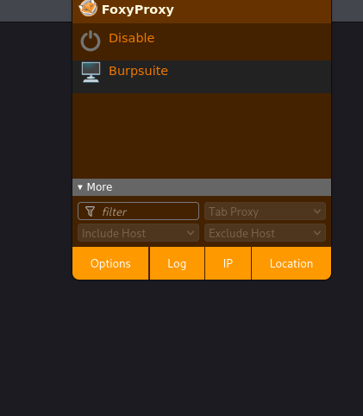
FoxyProxy menu showing the pre-configured “Burpsuite” proxy entry, ready to select.

Installing Burp's CA Certificate
This step is important: without it, HTTPS traffic may not route properly, or Firefox will repeatedly prompt to accept untrusted certificates.
- With FoxyProxy set to Burp, browse to http://burp
- Click CA Certificate to download it
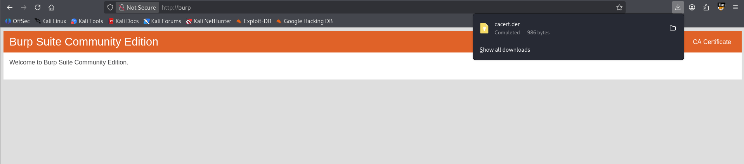
Burp Suite’s landing page at http://burp — the CA Certificate button (top right) downloads cacert.der.
- In Firefox, go to about:preferences#privacy
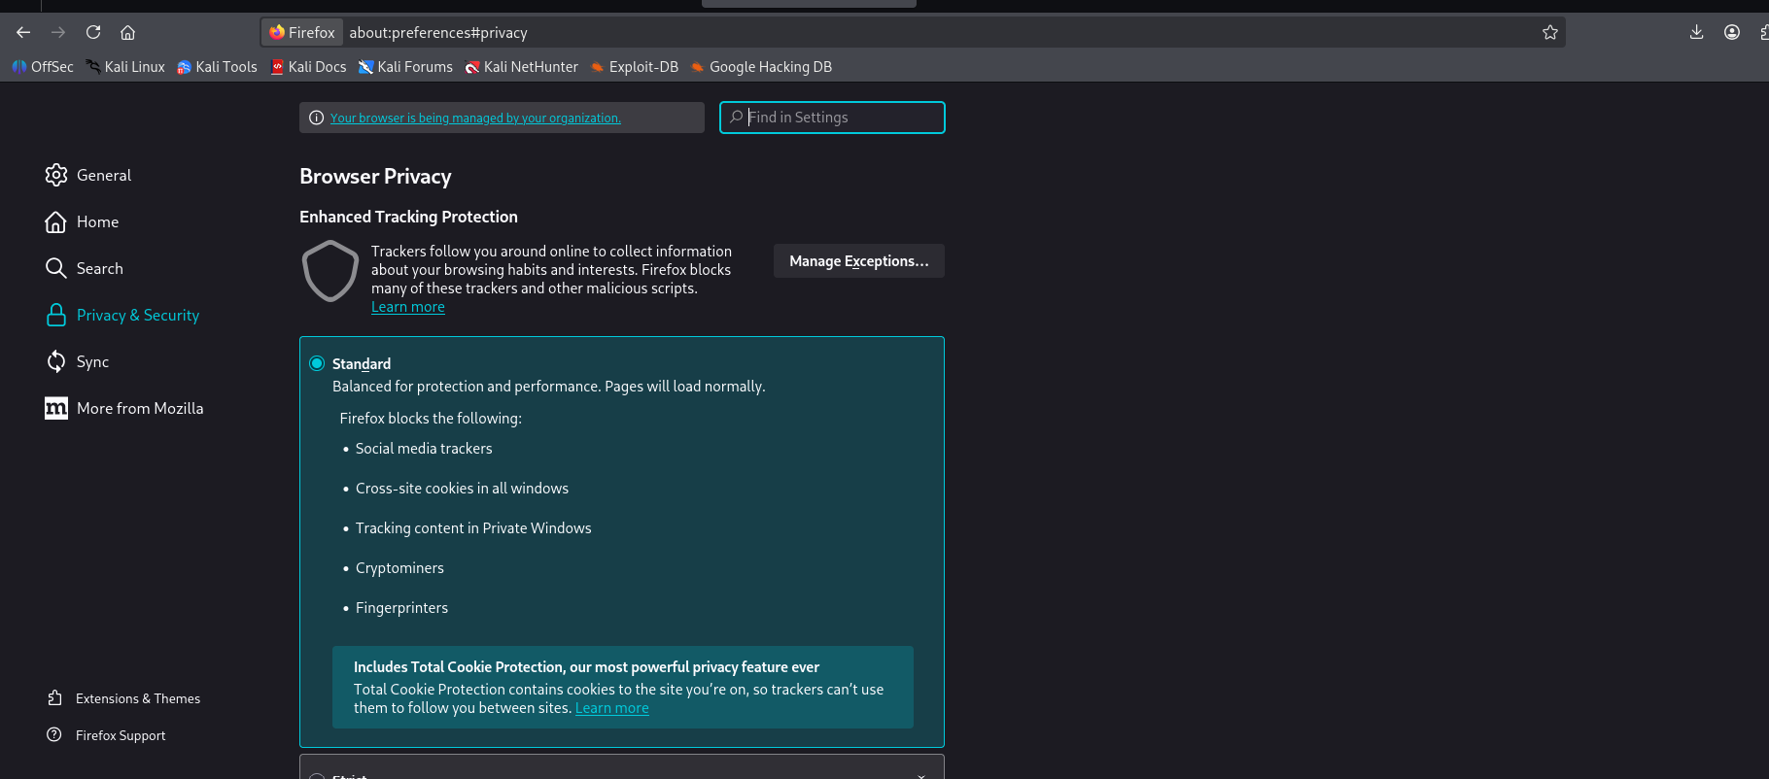
Firefox Privacy & Security settings page, opened via about:preferences#privacy.
- Scroll to the bottom of the page, to the Certificates section, and click View Certificates…
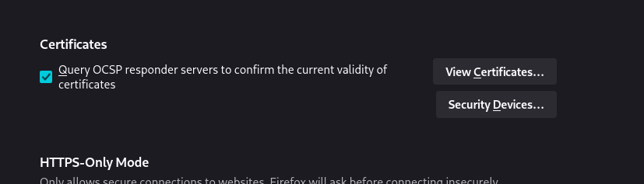
The Certificates section at the bottom of Firefox’s Privacy settings, with the View Certificates… button.
- In the Certificate Manager, select the Authorities tab
- Click Import, then select the downloaded cacert.der file
- Check both Trust this CA to identify websites and Trust this CA to identify email users, then click OK
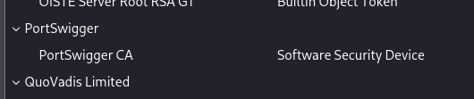
PortSwigger CA successfully listed under the Authorities tab in Firefox’s Certificate Manager — confirms the import worked.

4. Verifying the Proxy Works
Once FoxyProxy and the certificate are both set up, the setup can be verified in three checks:
- PortSwigger CA appears under Authorities in Firefox’s Certificate Manager
- HTTPS sites load cleanly in Firefox with no certificate warning
- Visited sites appear logged in Burp under Proxy → HTTP history
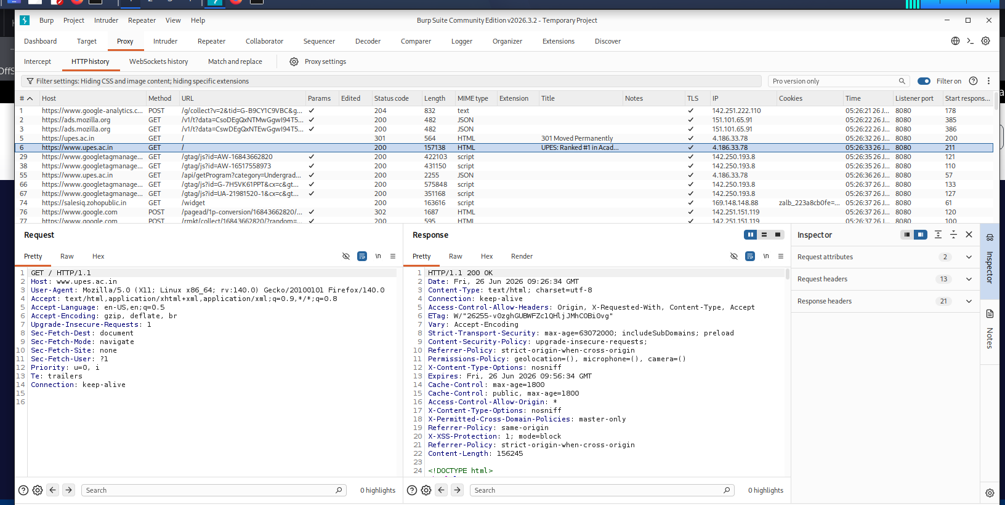
Burp’s HTTP history showing captured HTTPS traffic (e.g. upes.ac.in) with full request and response detail — confirms the proxy and certificate are both working end-to-end.

5. Intercepting Web Requests
With the proxy confirmed working, Burp can now be used to pause (“intercept”) a live request before it reaches the server, inspect it, and modify it before forwarding.

Turning Interception On
In Burp, go to Proxy → Intercept. Request interception is on by default; the button toggles between “Intercept is on” and “Intercept is off.”
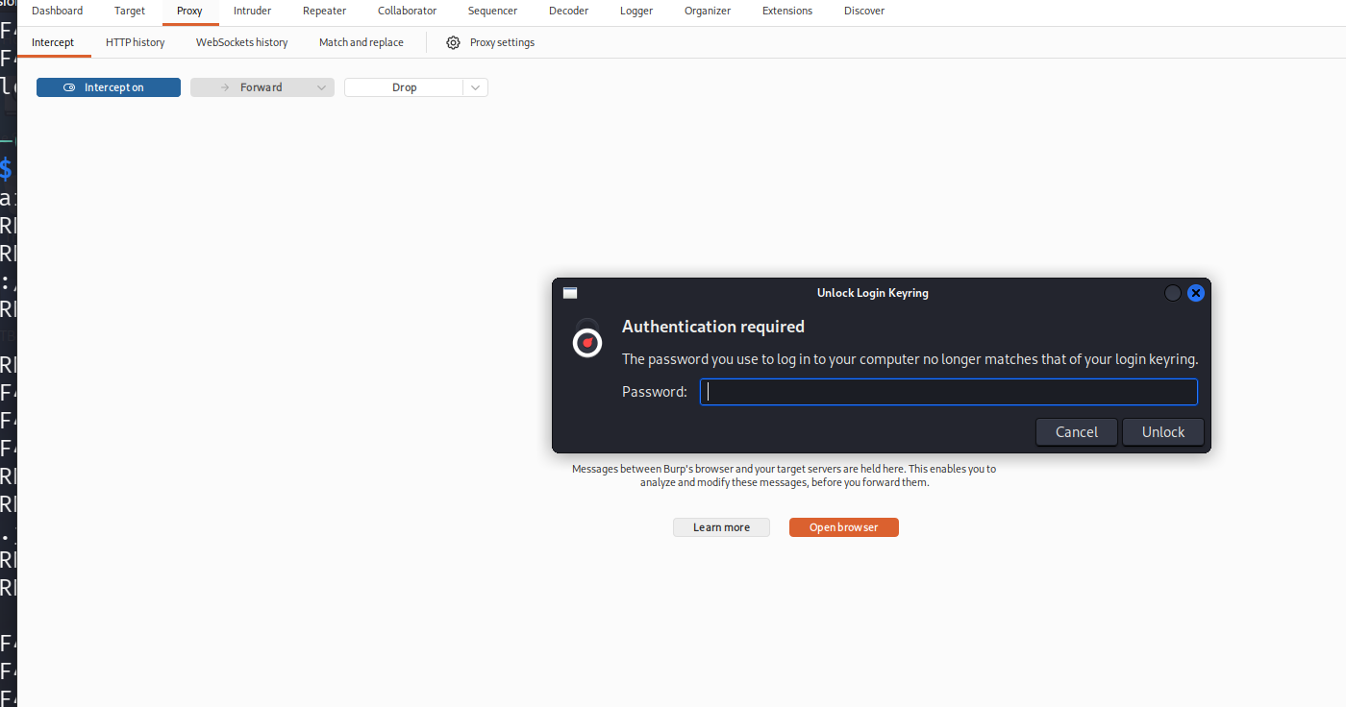
Proxy → Intercept tab with interception turned on, ready to capture the next request from the browser.

Catching the Target Request
With Intercept on, visiting a target page and triggering an action (e.g. clicking a “Ping” button on a form) causes the resulting request to pause in Burp instead of going straight to the server.
Note: Since all browser traffic is intercepted, unrelated background requests (e.g. Firefox telemetry to mozilla.com, captive portal checks) may appear first. Click Forward repeatedly on these until the request to the actual target IP/host shows up.
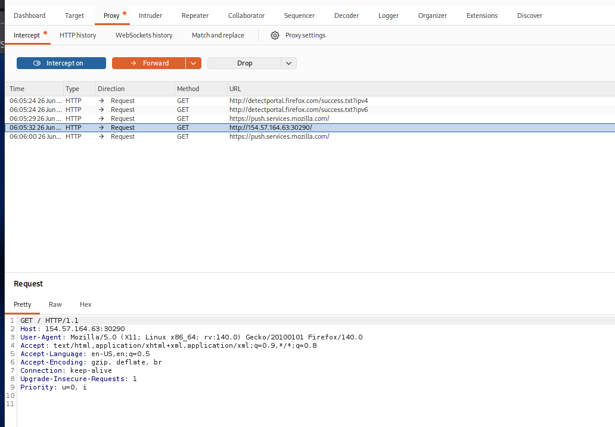
Several unrelated Firefox background requests queued in Intercept, with the target request (POST to the target IP) waiting at the bottom of the list.
Selecting the target request shows its full contents, matching the expected structure:
POST /ping HTTP/1.1
Host: <target-ip>:<port>
Content-Length: 4
Cache-Control: max-age=0
Accept-Language: en-US,en;q=0.9
Origin: http://<target-ip>:<port>
Content-Type: application/x-www-form-urlencoded
Upgrade-Insecure-Requests: 1
User-Agent: Mozilla/5.0 (X11; Linux x86_64) ...
Accept: text/html,application/xhtml+xml,...
Referer: http://<target-ip>:<port>/
Accept-Encoding: gzip, deflate, br
Connection: keep-alive

ip=1

Manipulating the Intercepted Request
The request body shown above (ip=1) is fully editable directly inside Burp’s request pane — no special mode needed, just click into the text and type.
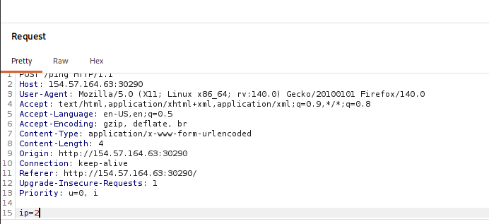
The ip parameter edited directly in Burp’s request pane, changing the value from 1 to 2 before forwarding.
This matters because the front-end form normally restricts the IP field to numeric characters only via JavaScript. That restriction lives entirely in the browser — intercepting the request after the browser has already built it bypasses that client-side check completely, since Burp can edit the raw HTTP body before it ever reaches the server.
Whether this can be exploited further depends entirely on whether the back end also validates the input, or simply trusts what the front end sent and uses it directly (for example, in a shell command). This is the foundation for testing many vulnerability classes through a proxy, including:
- SQL injection
- Command injection
- Upload bypass
- Authentication bypass
- XSS
- XXE
- Error handling / deserialization issues

Forwarding & Observing the Result
After editing the body, clicking Forward sends the modified request on to the server. The response — visible either on the page in the browser, or directly in Burp’s Response pane for that same request — shows how the back end actually handled the modified input.
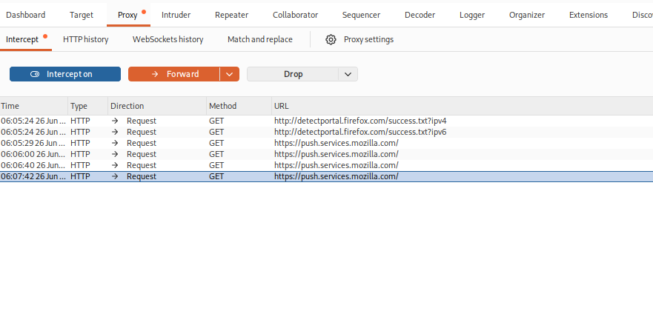
The intercepted POST /ping request selected in HTTP history, ready for the body to be inspected and edited before forwarding.
Note: If a request goes through before it can be edited, it's likely because Intercept was off, or earlier unrelated requests were forwarded past without checking the Host column first. Turn Intercept back on, retrigger the action, and check each request's Host/URL before forwarding.

Summary: Burp's core proxy workflow is Open Browser (or Firefox + FoxyProxy + CA cert) → Intercept on → trigger the request → edit the body/headers in the request pane → Forward → check the response. This loop underlies almost every manual web request manipulation technique used in web application penetration testing.

